|  |
| --- |
| Programming Project 1 |
| CS 3010 – Section 1 |

|  |
| --- |
| Kevin De La Torre  010806250 |

Manual entry of coefficients:

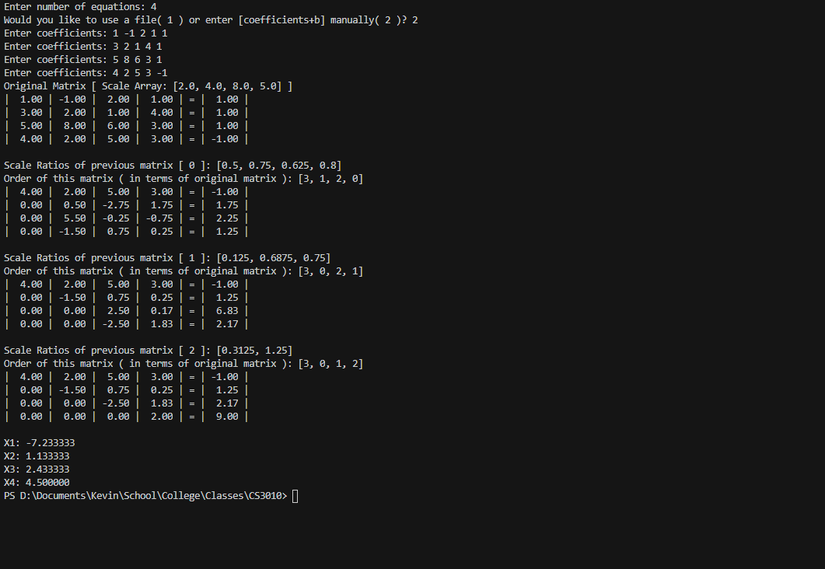

Using a file ( data.txt ) to enter coefficients: